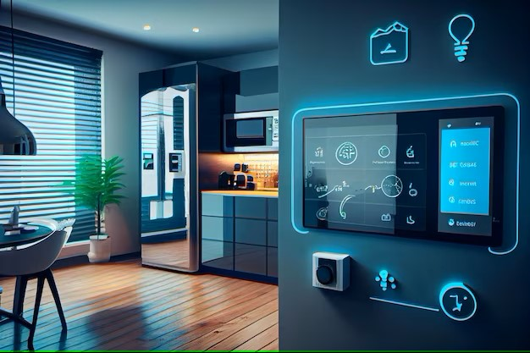

SMART ENERGY MANGEMENT SYSTEM FOR SMART HOMES

(SEMS)

**INTRODUCTION**

A Smart Energy Management System (SEMS) is a technology that uses smart devices to control and monitor the energy consumption in homes.

**FEATURES**

1. **Smart Energy Monitoring**
2. **Insight – Driven Optimization**
3. **Seamless Integration**
4. **Personalized User Interface**
5. **Diversified Energy Integration**
6. **Security and Privacy**

**Smart Energy Monitoring**

**Real- time Insights**

Monitor your energy consumption in real-time gaining insights into the usage pattern.

**Detailed reporting**

Analyse comprehensive data reports to identify areas for improvement and make informed decisions.

**Customizable Alert**

Set personalized alerts to stay informed about spikes in energy usage or potential issues.

**Insight – Driven Optimization**

1

Analyze: Our advanced AI algorithms analyze your energy usage data to identify patterns and opportunities for optimization.

2

Optimize: Intelligent energy optimization algorithms automatically adjust your home's systems to reduce energy consumption and costs

3

Adapt: The system continuously learns and adapts to your preferences and behaviours, ensuring optimal performance over time.

**Seamless Integration**

**Temperature Control:**

Integrate with your smart thermostat for enhanced energy management.

**Lighting Automation**:

Optimize your home's lighting for maximum efficiency and convenience.

Appliance Integration:

Connect your smart appliances to the system for comprehensive control.

Personalized User Experience

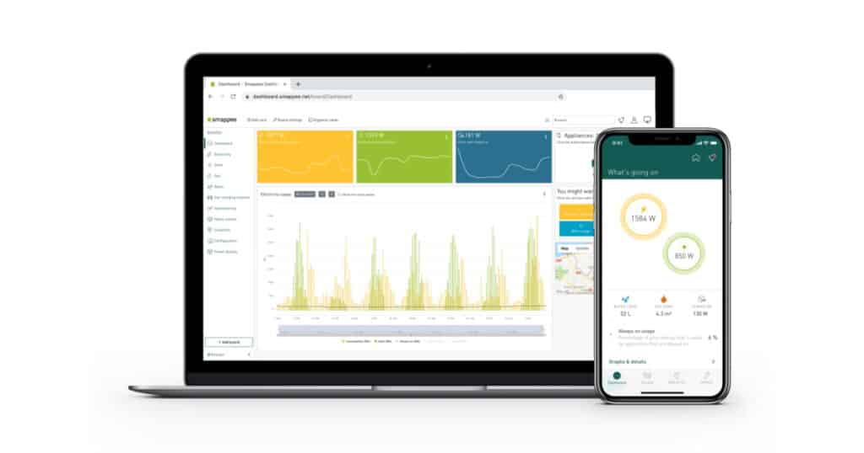

Customizable Dashboard

Tailor the intuitive user interface to your preferences and needs.

Voice Commands

Effortlessly control your home's energy systems using voice commands.

Mobile App:

Monitor and manage your home's energy from anywhere with our user-friendly mobile app.

Diversified Energy Integration

Renewable Sources: Seamlessly integrate renewable energy sources, such as solar panels, for a sustainable energy solution.

Grid Integration: Leverage the power of the grid to ensure a reliable and cost-effective energy supply.

Energy Storage: Incorporate energy storage solutions to optimize your energy usage and minimize waste

Secure and Private

1.Data Encryption

Protect your personal information and energy data with robust encryption protocols.

2 Access Control

Implement multi-factor authentication and user-level access controls to ensure your home's security.

3 Privacy

Safeguards Prioritize your privacy with transparent data policies and user-centric controls.

The Future of Smart Energy Management

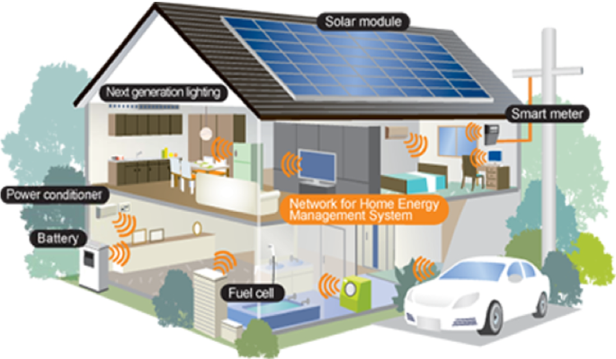

Embrace the future of energy management with our cutting-edge smart home solution. Elevate your home's efficiency, sustainability, and convenience, while enjoying unparalleled control and peace of mind. Experience the power of smart energy management and transform your home into a sustainable, future-ready oasis.